4.1 Graphical User Interface (GUI)

In the beginning of the GUI implementation, the sketch was drawn on the paper, and that helped to understand better what the system must consists of. It was created a simple interface in JavaFX, in which it was used text fields, combo boxes, buttons, lists, radio buttons, check boxes, date picker, choice boxes.

One of the most important method from the program is “Make reservation”. This method was designed on two pages, each representing a step. In first step, GUI was build taking into consideration that the user must search through the list of Tours, for the trip or travel, that customer needs to reserve. As seen in the picture bellow at this step it was used in implementation a text area for notes, 3 text fields for searching, and a list to display the tours.

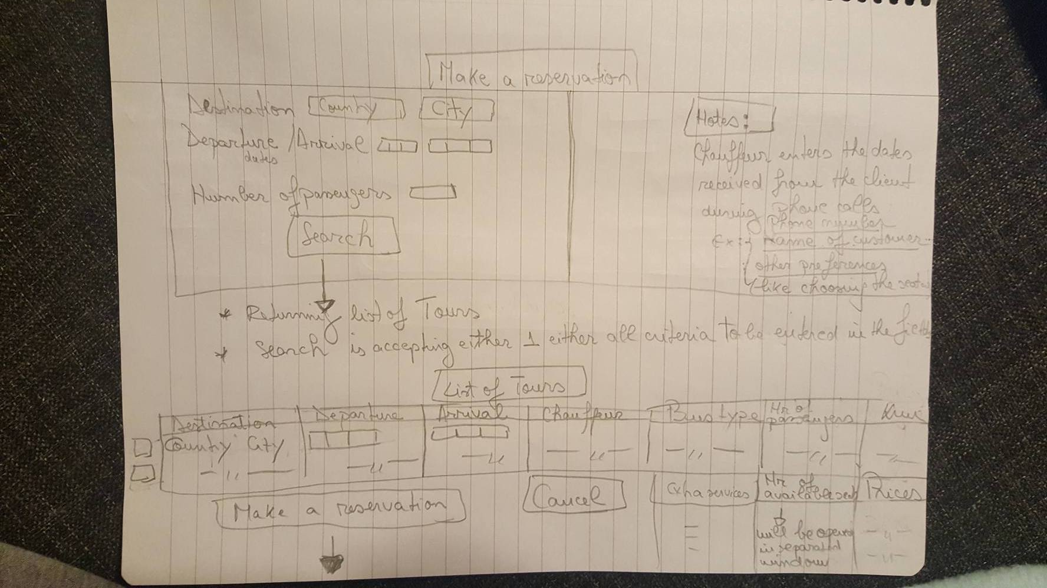

In the second step, GUI was developed so the user could enter the dates about the customer, passengers, price for extra services and discount. The user can make a reservation by selecting the customer, passengers from the lists. So, it was used 2 lists, date picker for birthday, and text fields to enter the dates.

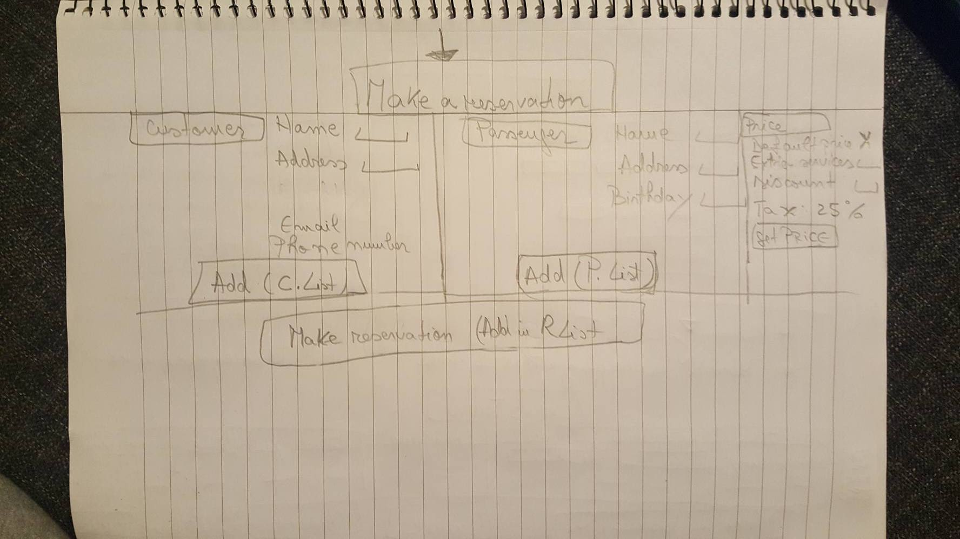

The result looks a little different, as they are better organized and implemented in JavaFX. It must be mentioned that, after clicking Choose Tour, the notes from first step will automatically appear in the second step of making reservation, with the same data, only if the user typed into the note section. Notes are a convenient way of storing information which the user needs in the workspace.

